**Advanced Topics in Neuroscience HW 2**

Aliakbar Mahmoodzadeh 98106904

# Step 1

**Data & Task Description**:

The goal of this task is to calculate the Peri-Stimulus Time Histogram (PSTH) for each unit and then plot the average PSTH for each condition of the task.

First, let's break down the components of the task:

1. There are 481 single units recorded from an array. Each unit has spike times for 192 trials, which are stored in the 'Trls' subfield.
2. The length of each trial is 3.2 seconds (1.2 seconds before cue onset to 2 seconds after cue onset).
3. The 'Cnd' subfield contains the trials in each group of the task conditions.
4. The 'Value' subfield within 'Cnd' shows the expected value and the cue location in the task.

Here's a general approach to achieve this task:

1. For each unit, calculate the PSTH by binning the spike times around the cue onset time. The PSTH is typically created by dividing the trial into small bins (e.g., 50 ms) and counting the number of spikes that occurred in each bin. This process should be performed for all trials in each condition.
2. Calculate the average PSTH for each condition by averaging the PSTH values across trials for each condition. This will give you a single average PSTH for each condition.
3. Plot the average PSTH for each condition. This can be done using subplots or separate plots for each condition. The x-axis should represent time (relative to cue onset), and the y-axis should represent the average spike count per bin.

**Plots:**

Also, we plot some Units as bar-chart for knowing better information:

First of all we plotted the some Units:

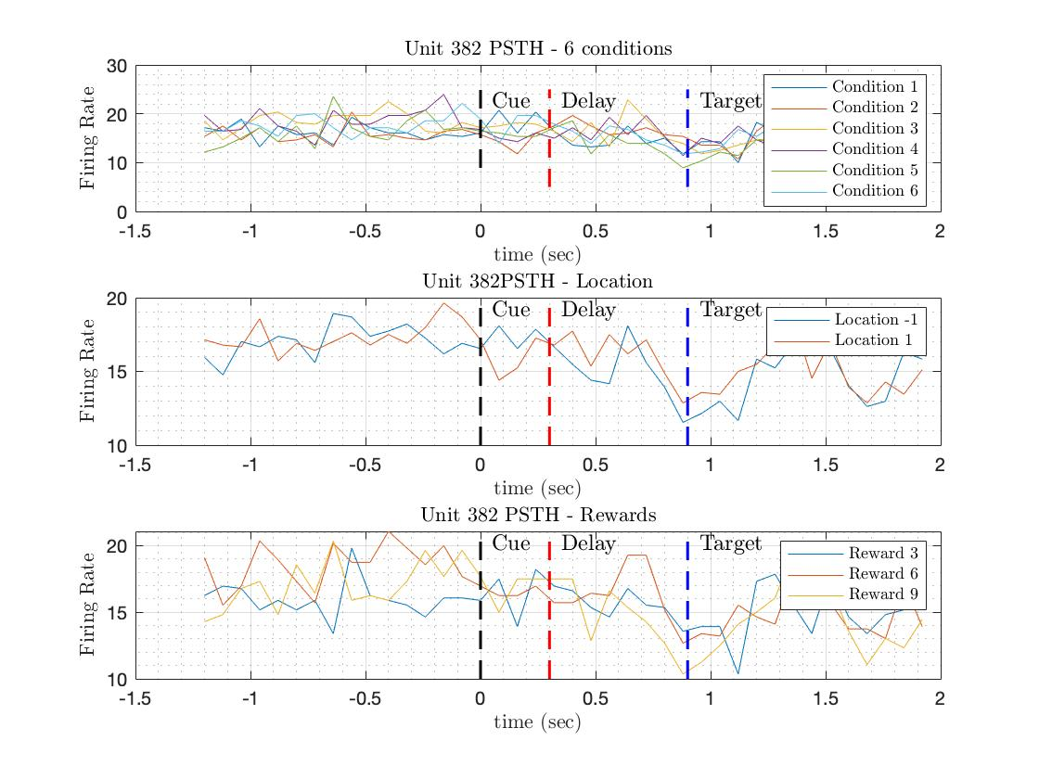

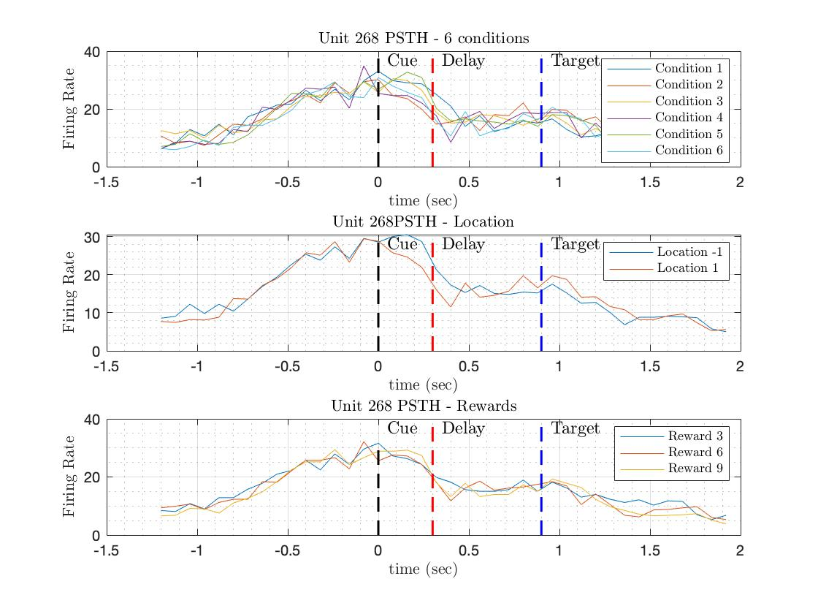

As you see, unit number 123 firing rate will not significantly change over time, and it seems it doesn’t code anything in our task.

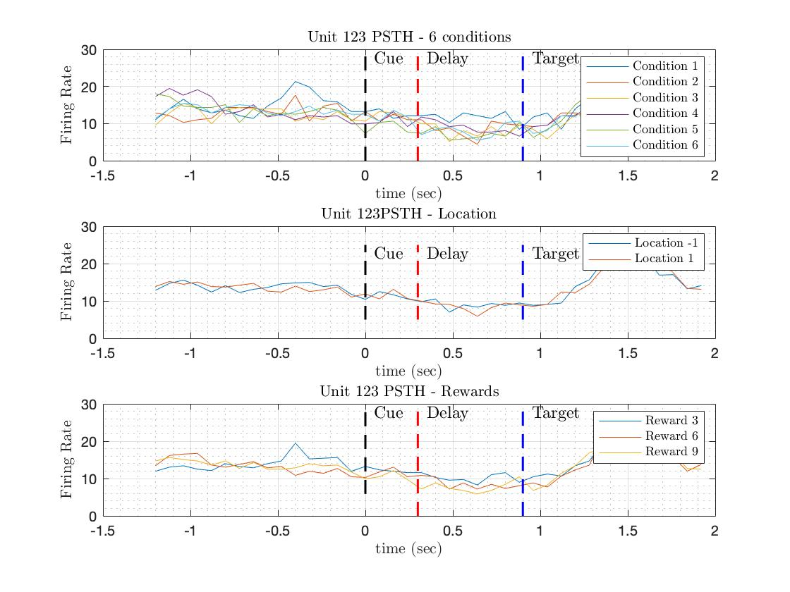

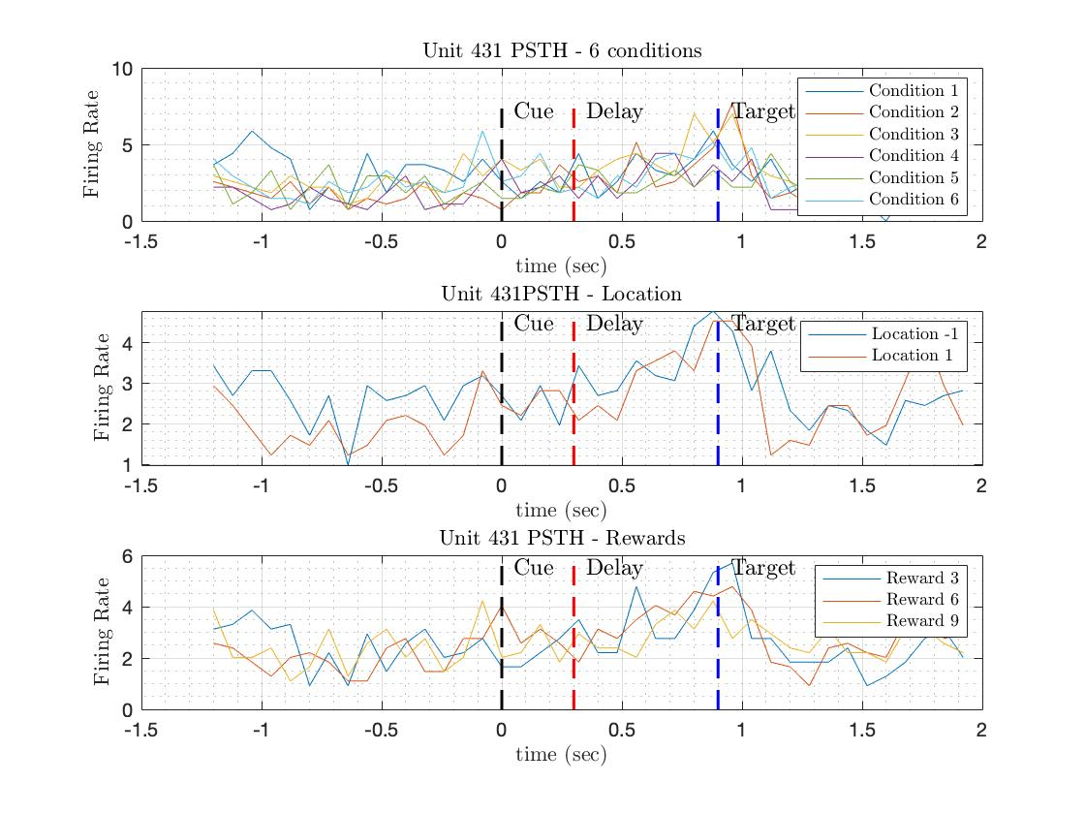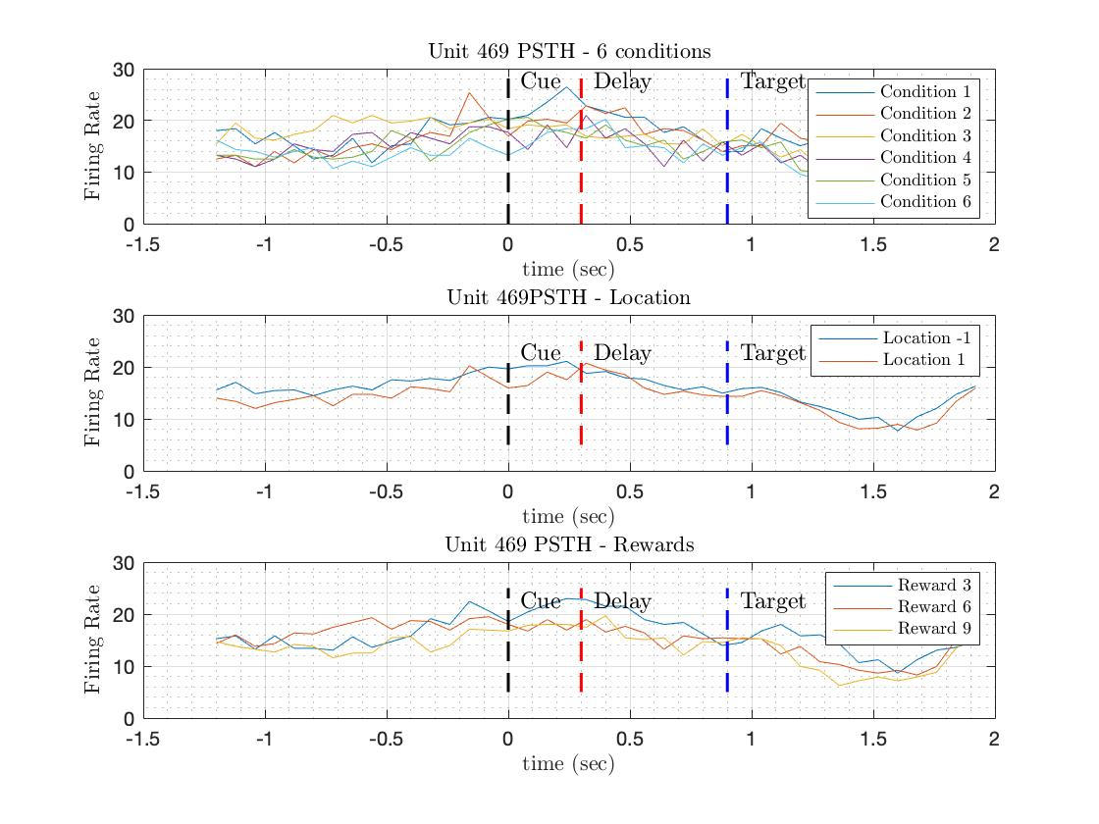

Also, I plot the Bar-Chart for some Units:

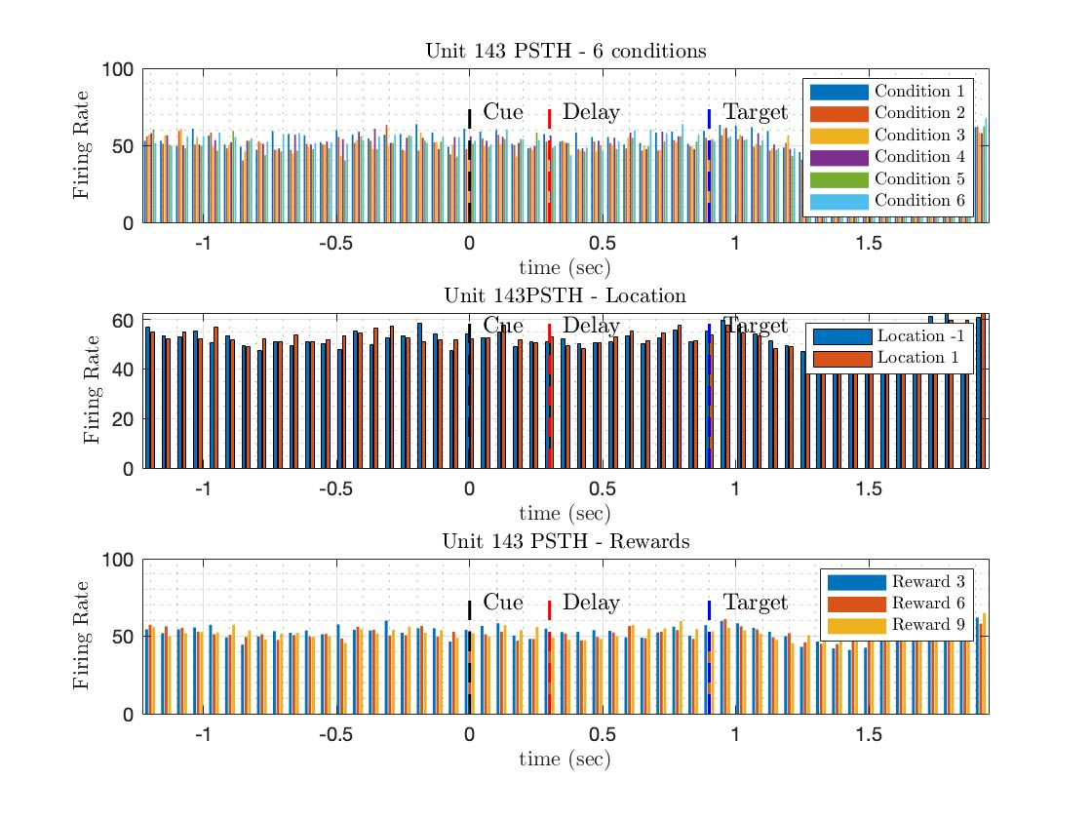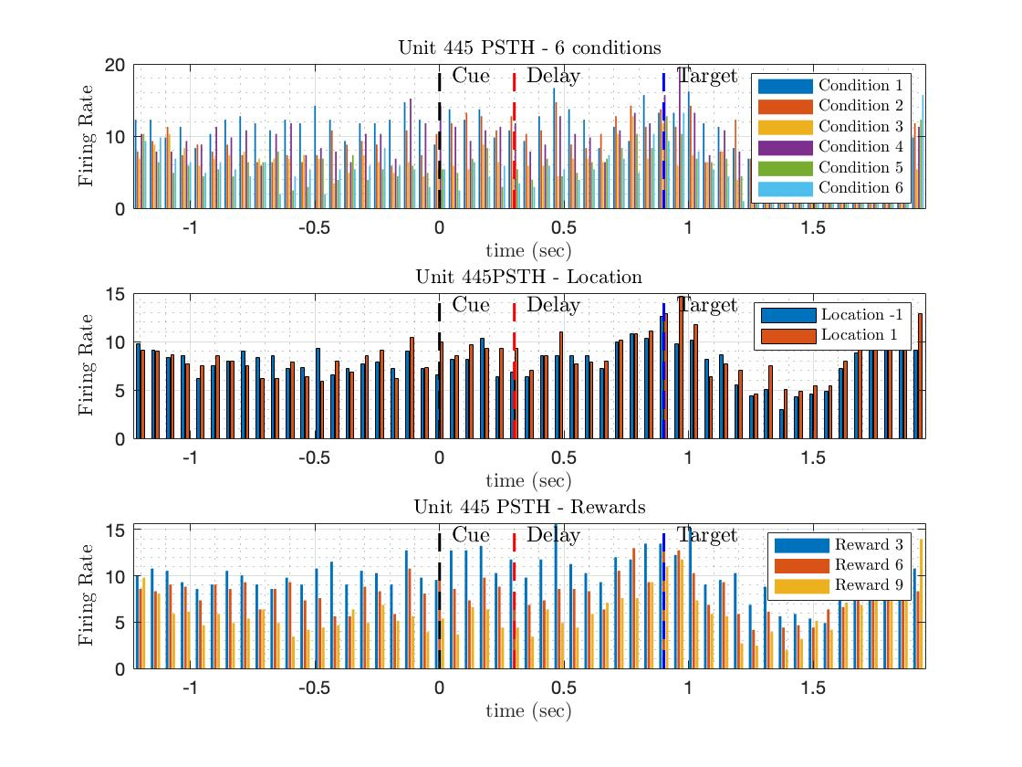

As you see, unit number 272 firing rate won‘t significantly change over time, and it seems it doesn’t code anything in our task.

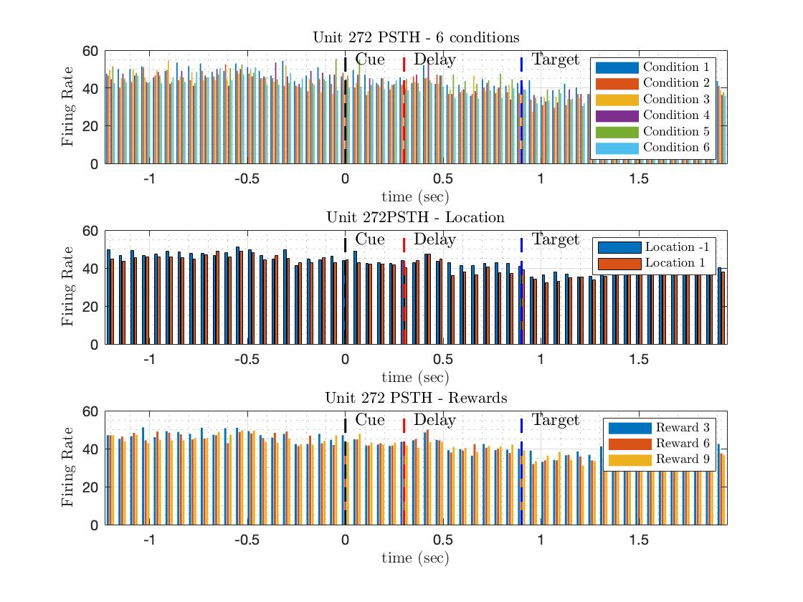

**average PSTH for each condition of the task:**

1. **Average of PSTH for each Condition:**

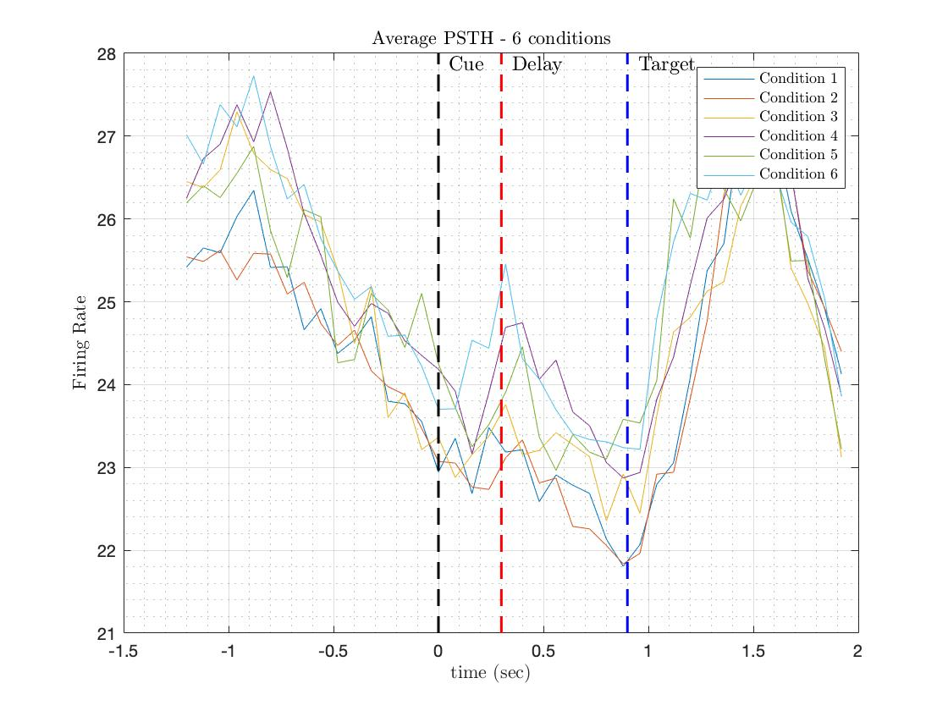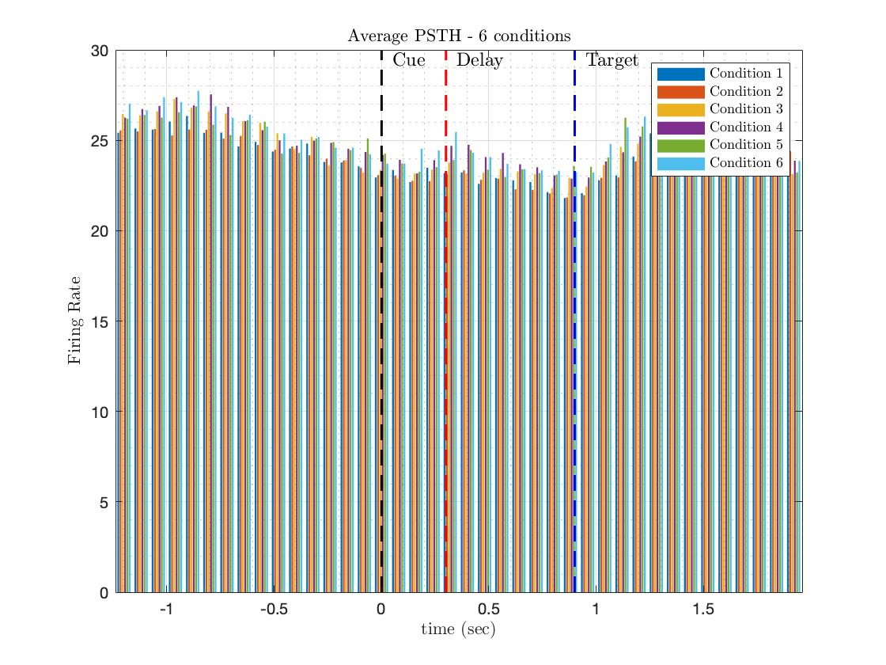

1. **Average of PSTH for each Reward:**

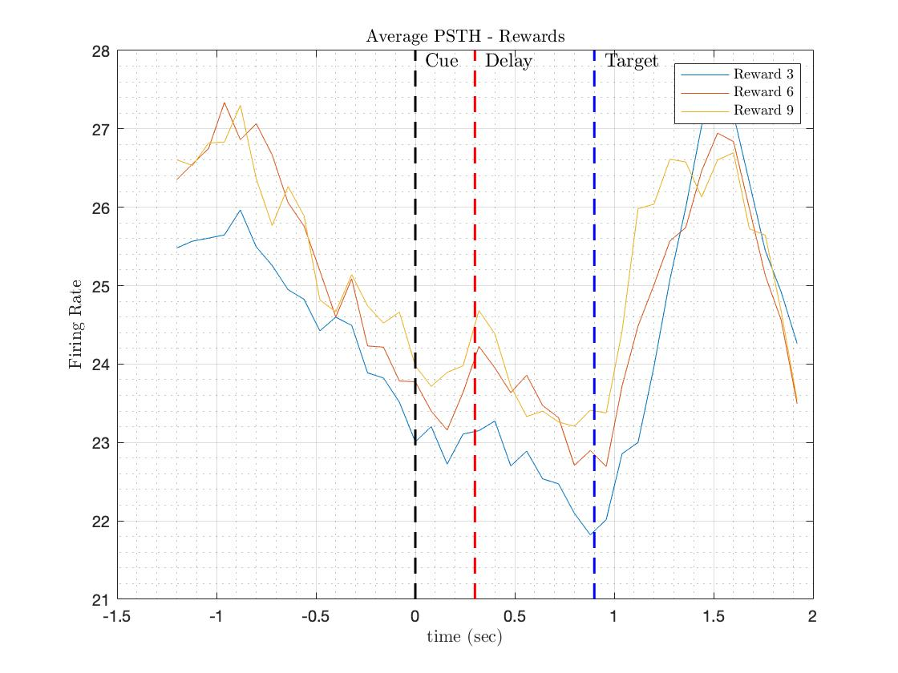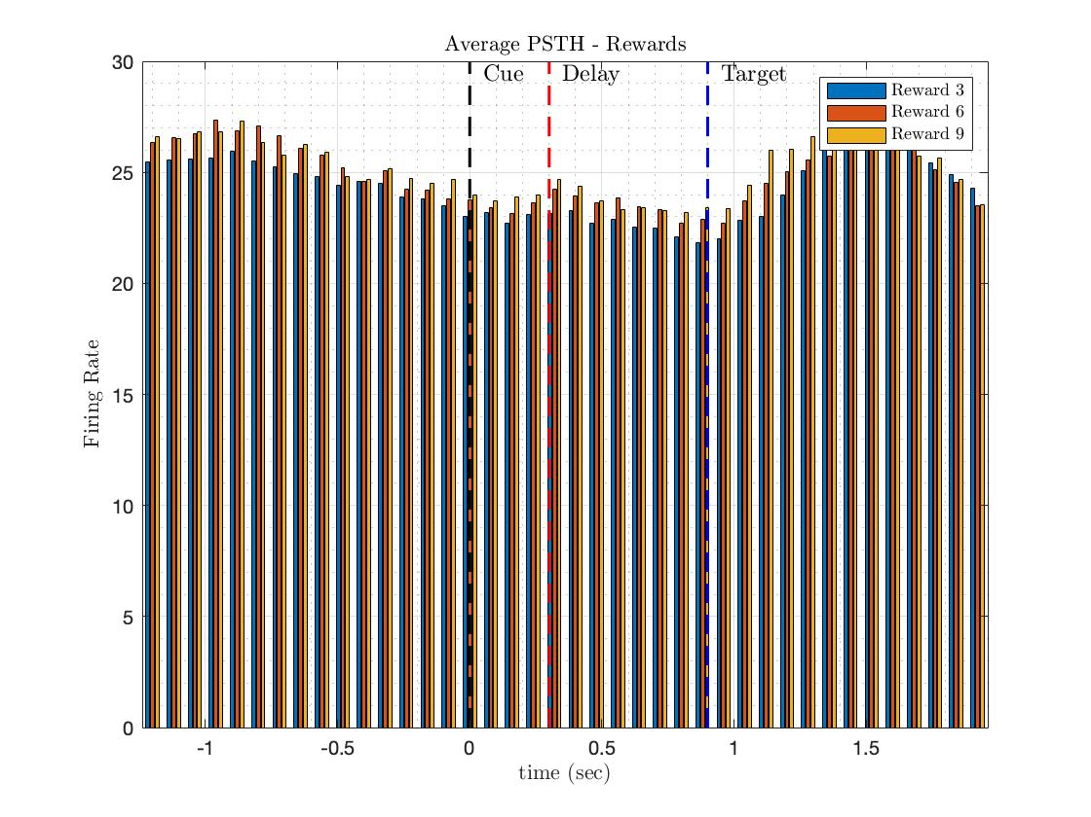

1. **Average of PSTH for each Location**

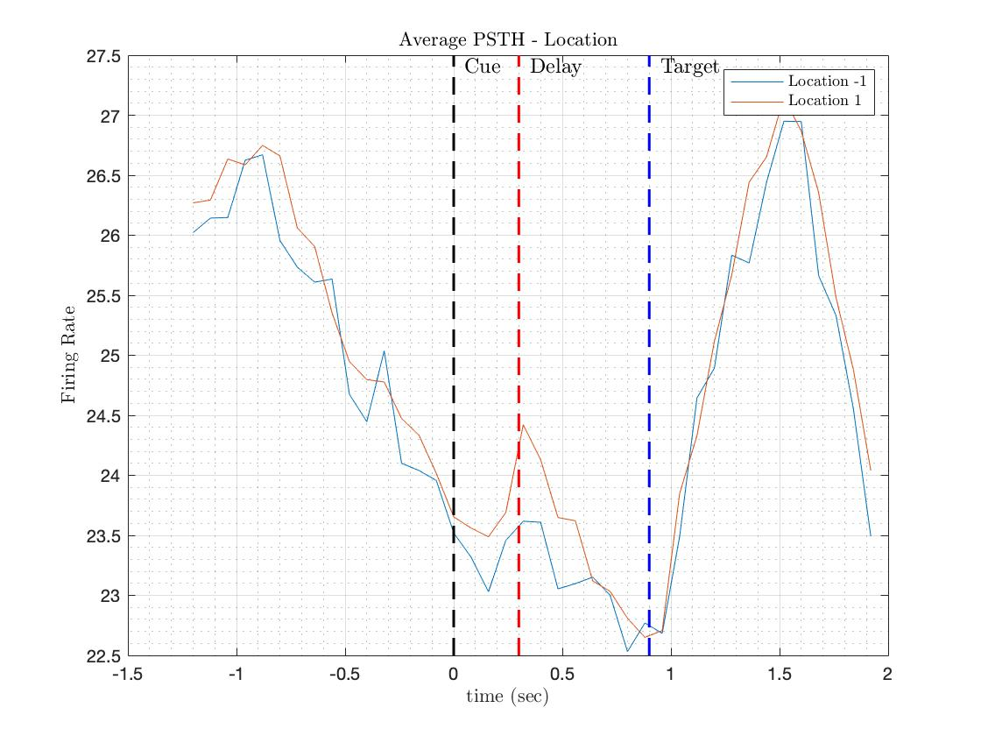

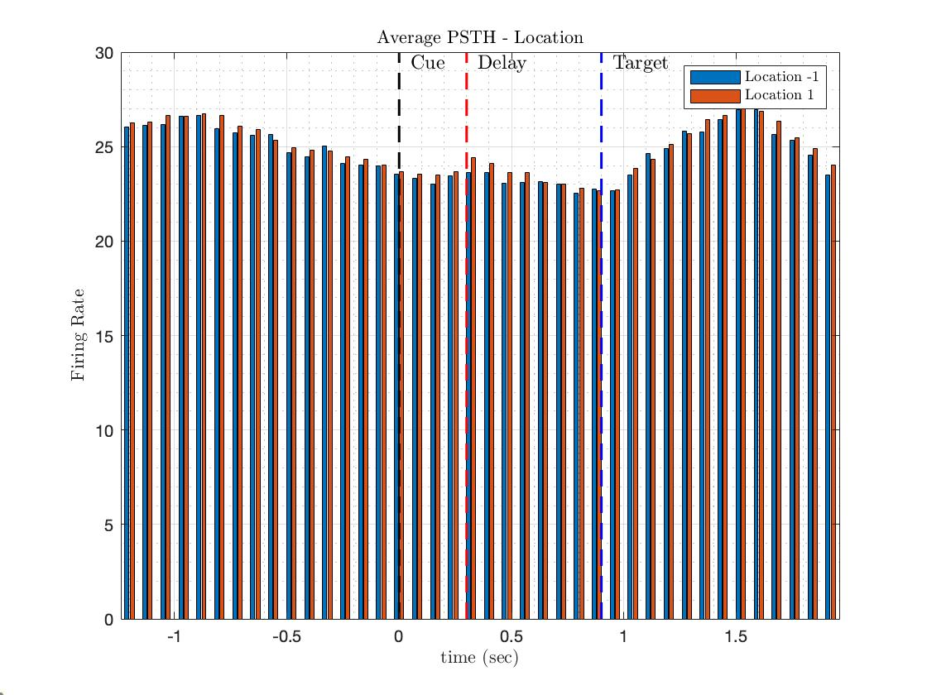

**Conclusion:** The average firing rate across all units does exhibit an increase in activity after stimulus onset, reaching approximately 27 Hz. However, there is no discernible difference in the firing rate patterns across various task conditions. This suggests that the average firing rate for all units needs to provide specific information about each condition's neural representation.

**Question:**

**Q1:** Are the PSTH of different units act in the same way?

No, not all units display a consistent increase in firing rate after stimulus onset. For example, unit 123 does not show such an increase. Additionally, the range of firing rates varies among the units, further highlighting the diverse response patterns across the population of recorded neurons.

**Q2**: Could you infer the encoding of task parameters from the average PSTH?

No, as demonstrated in Figures of Unit 123, there is no significant difference in neuronal responses for tasks specific to direction or reward. This suggests that the observed patterns are not strongly influenced by these particular task conditions.

**Unit 123:**



# Step 2

In single-unit analysis using the Generalized Linear Model (GLM), the goal is to identify which individual units (neurons) are significantly encoding the task conditions, such as the expected reward value and cue location. This involves regressing the neural responses against these two parameters, allowing you to determine how strongly these factors are represented in the recorded neural activity.

For do this step we should do:

1. Create a design matrix for the task conditions (expected reward value and cue location). Each row of the design matrix represents a single trial, and each column corresponds to a task condition. The design matrix will have as many rows as trials and two columns (one for expected reward value and one for cue location).
2. Perform a GLM analysis by fitting a model that relates the neural responses (dependent variable) to the task conditions (independent variables). This can be done using a function like **glmfit** in MATLAB, where you input the design and neural response matrices.
3. Assess the significance of the model fit by examining the p-values and confidence intervals associated with the regression coefficients. Units with low p-values (e.g., less than 0.05) can be considered to encode the task conditions significantly.
4. Analyze the results to determine which units show significant encoding of reward expected value and cue location. You can visualize the results by plotting the regression coefficients, p-values, or confidence intervals for each unit.

For each unit, the p-value of each time point is calculated. A threshold is considered for the p-value to see which units at which time points best indicate the conditions.

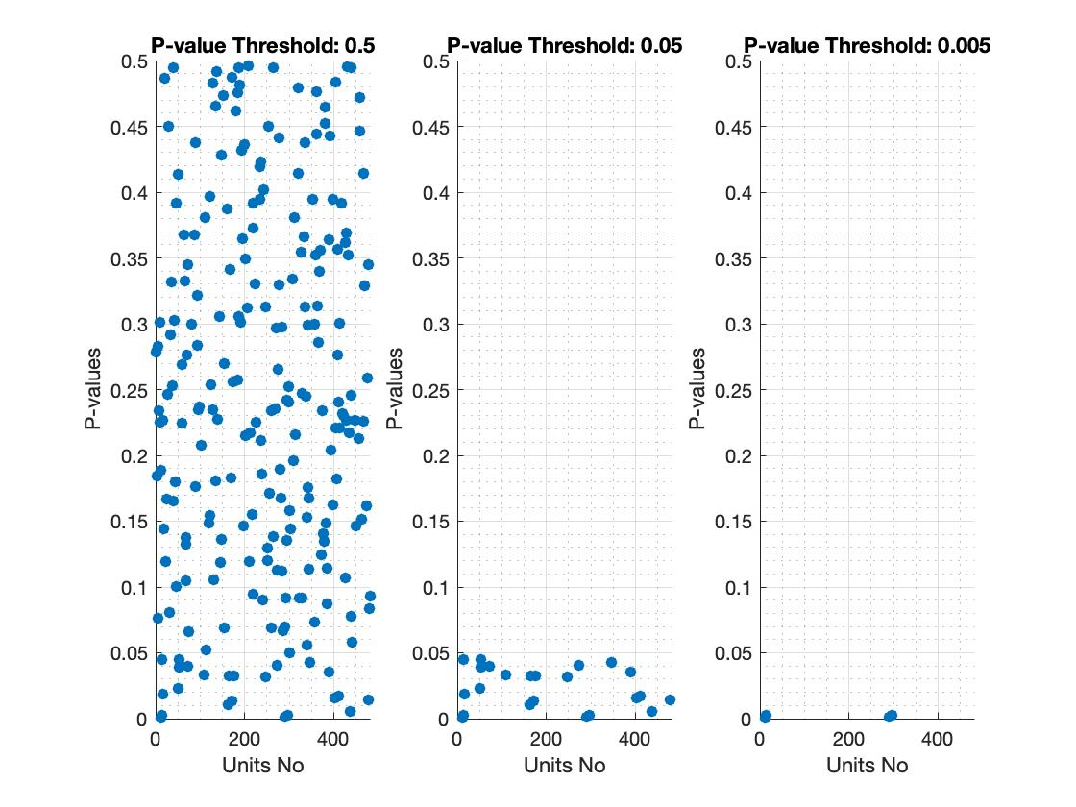

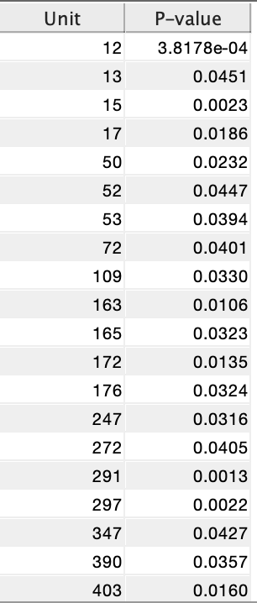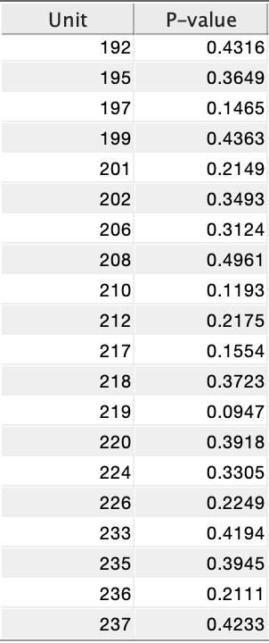 And in this table I bring each Unit with its P-value:

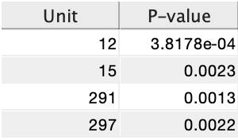So these are significant P-Value:

**Furthermore: (Plot for Unit 12, 172, 52, and 291 for some condition)**

The Purple and black ellipses are centered at the mean of each condition, and the long and short diameters show the std of each unit in the condition.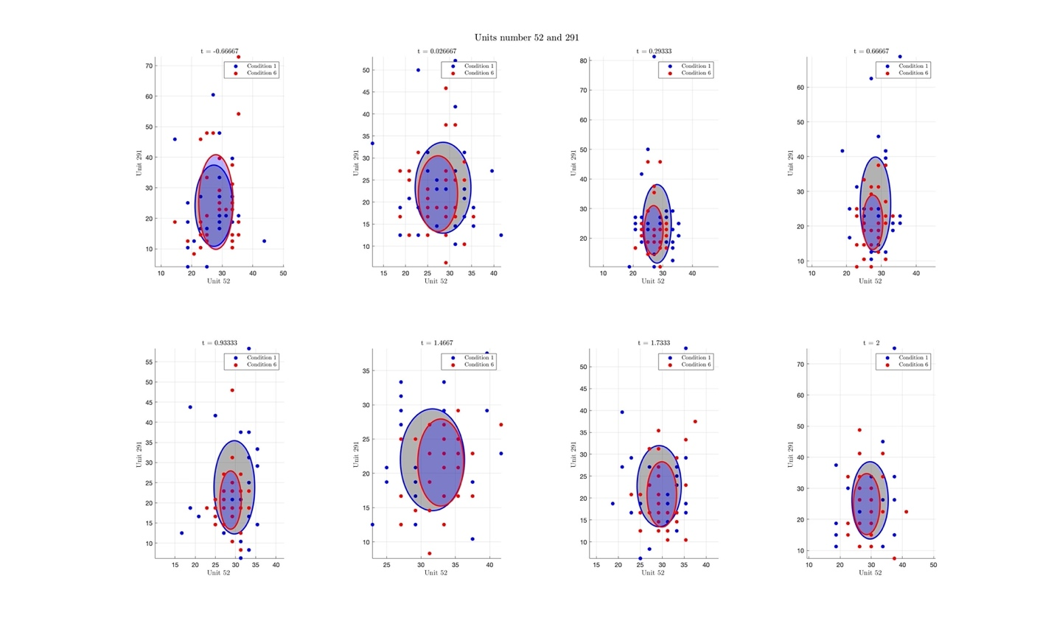

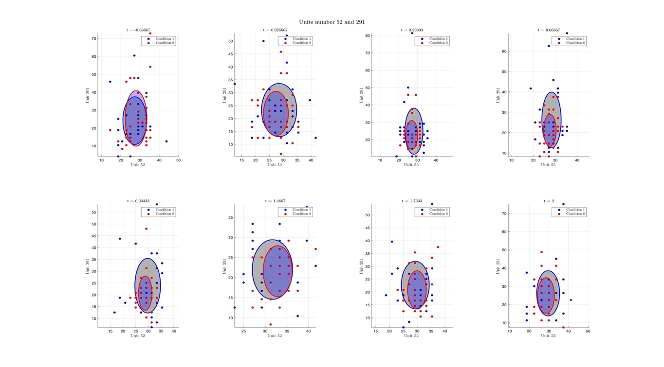

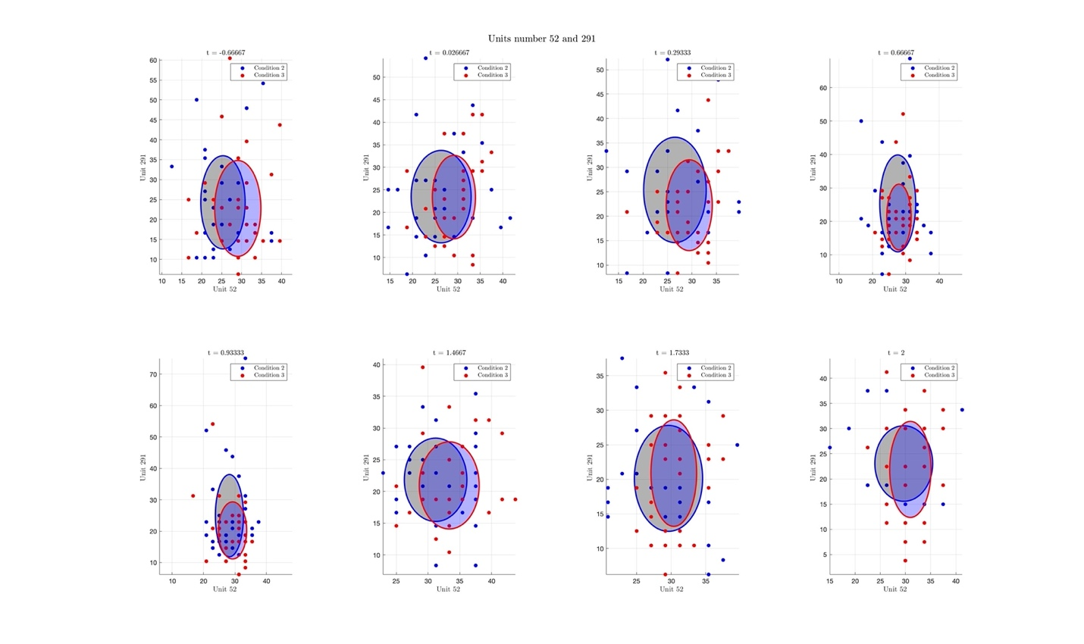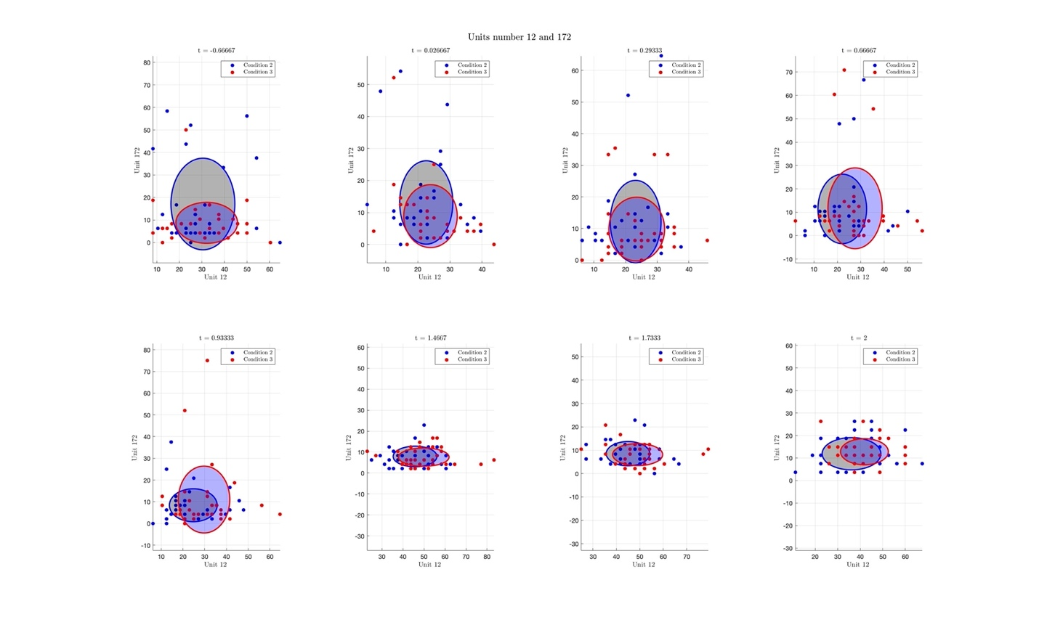

# Step 3

We calculate each unit's average response across different conditions, creating a large data matrix. We then analyze this data using principal component analysis to find patterns. Our results show that one specific condition (reward = 3) behaves differently from the others, which can be encoded by our analysis method.

The PCA algorithm is applied to trials averaged over the conditions with the same direction:

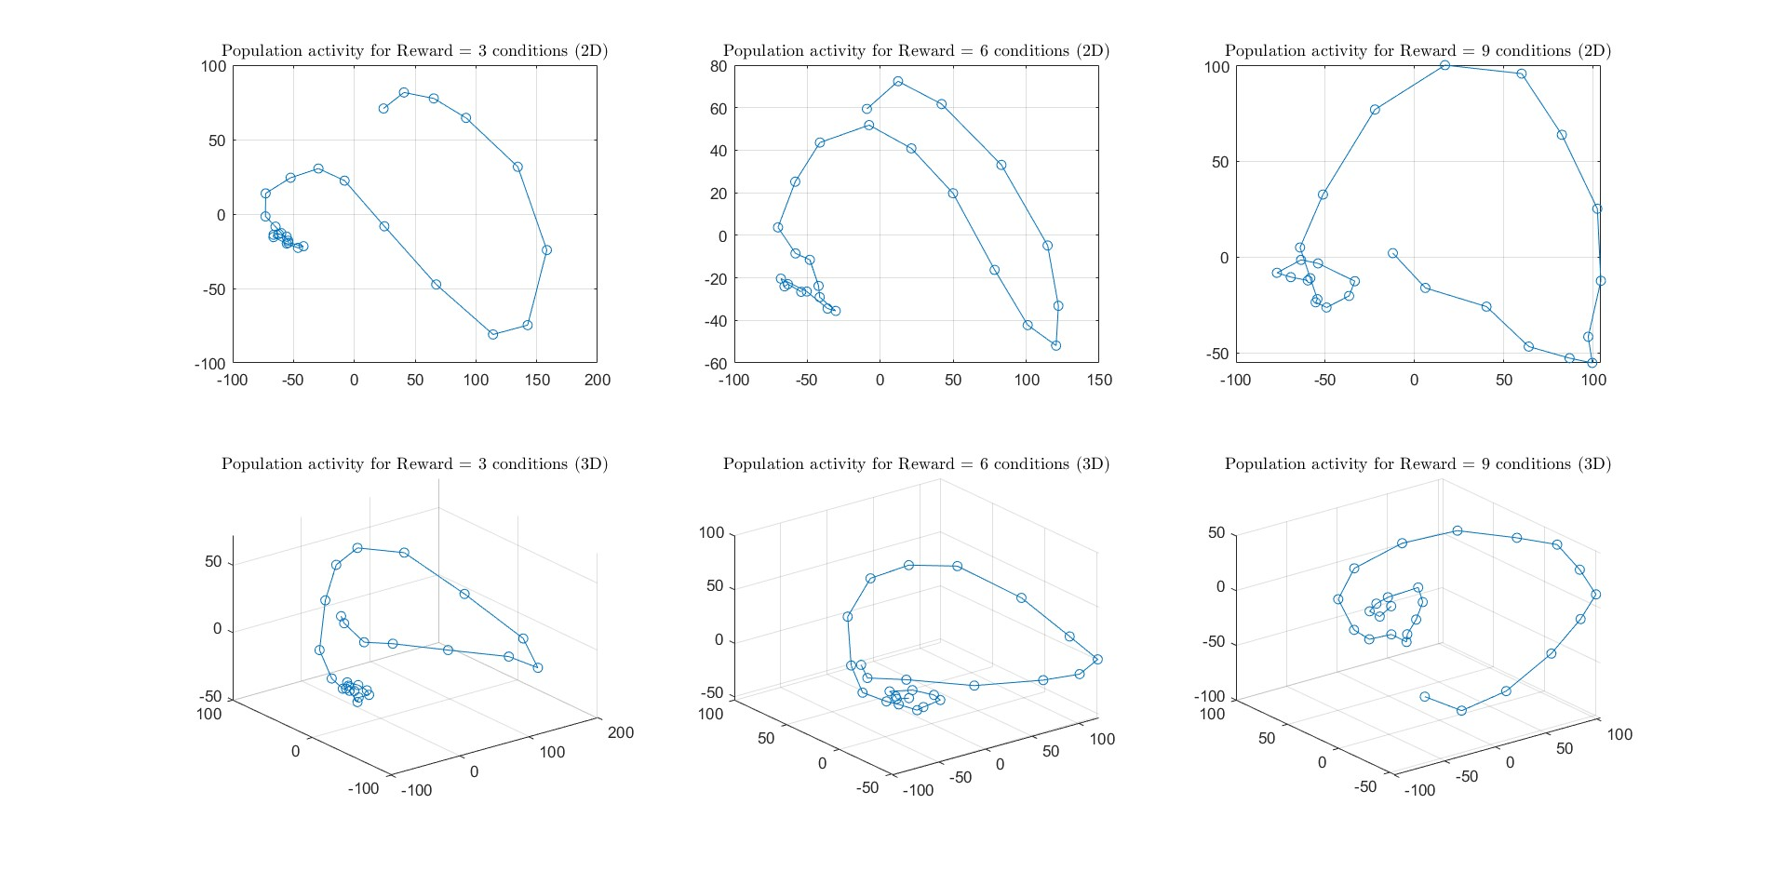

Based on the 2D graphs, we can see that the reward = 9 condition behaves differently compared to the other two reward values. But the 3D charts have the same behavior!

The population activity in lower dimensions (2D and 3D) averaged over all six conditions.

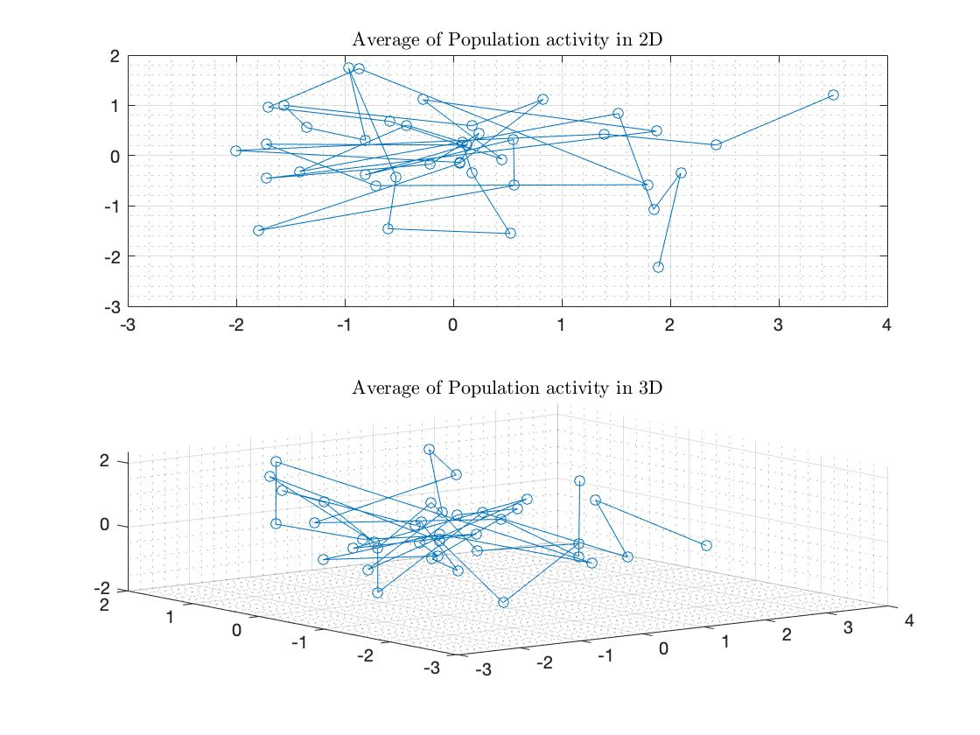

# Step 4

I used the CFR method, and it is uploaded on GitHub with this link (<https://github.com/gamaleldin/CFR>)

And this is the result:

Population activity in 2D and 3D for conditions after shuffling by CFR method.

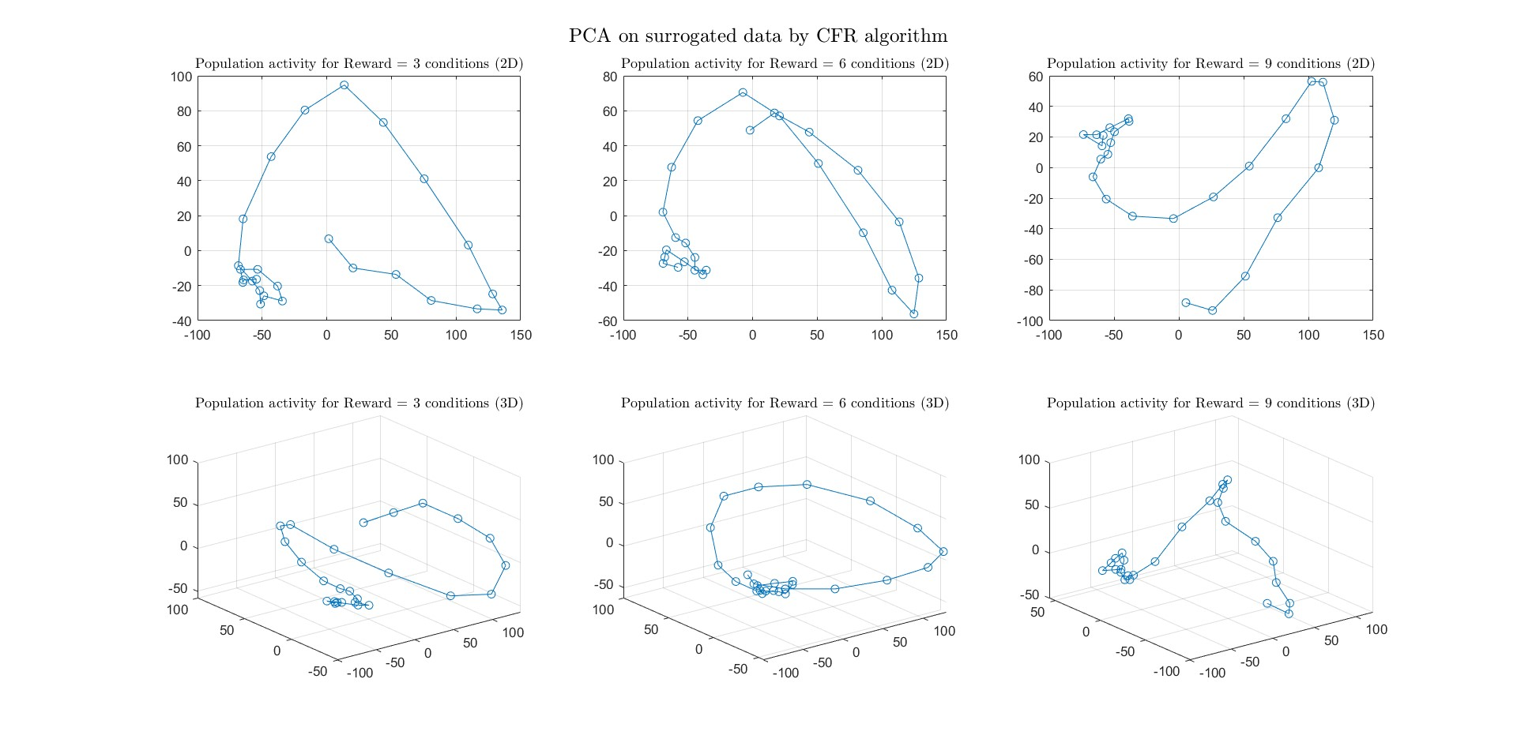

**Question:**

Based on your shuffling, does the population data teach us more than what is expected from single-unit analysis?

**Answer:**

The unshuffled data show distinct patterns and locations for different conditions. However, after shuffling, all conditions have the same pattern and become very similar. This means the conditions are not as well-represented after shuffling as before. Therefore, the combined activity of all units provides valuable information about cue locations and reward values.